1. While vcredist_x86.exe installation: "This program has known compatibility issues"

Remarks: This most probably occured due to x86 architecture program being installed on 64 bit machine.

Possible solution: temporary internet access to the machine in question, as this is a frequent problem with working solutions available online.

2. While SQL 2005 installation:

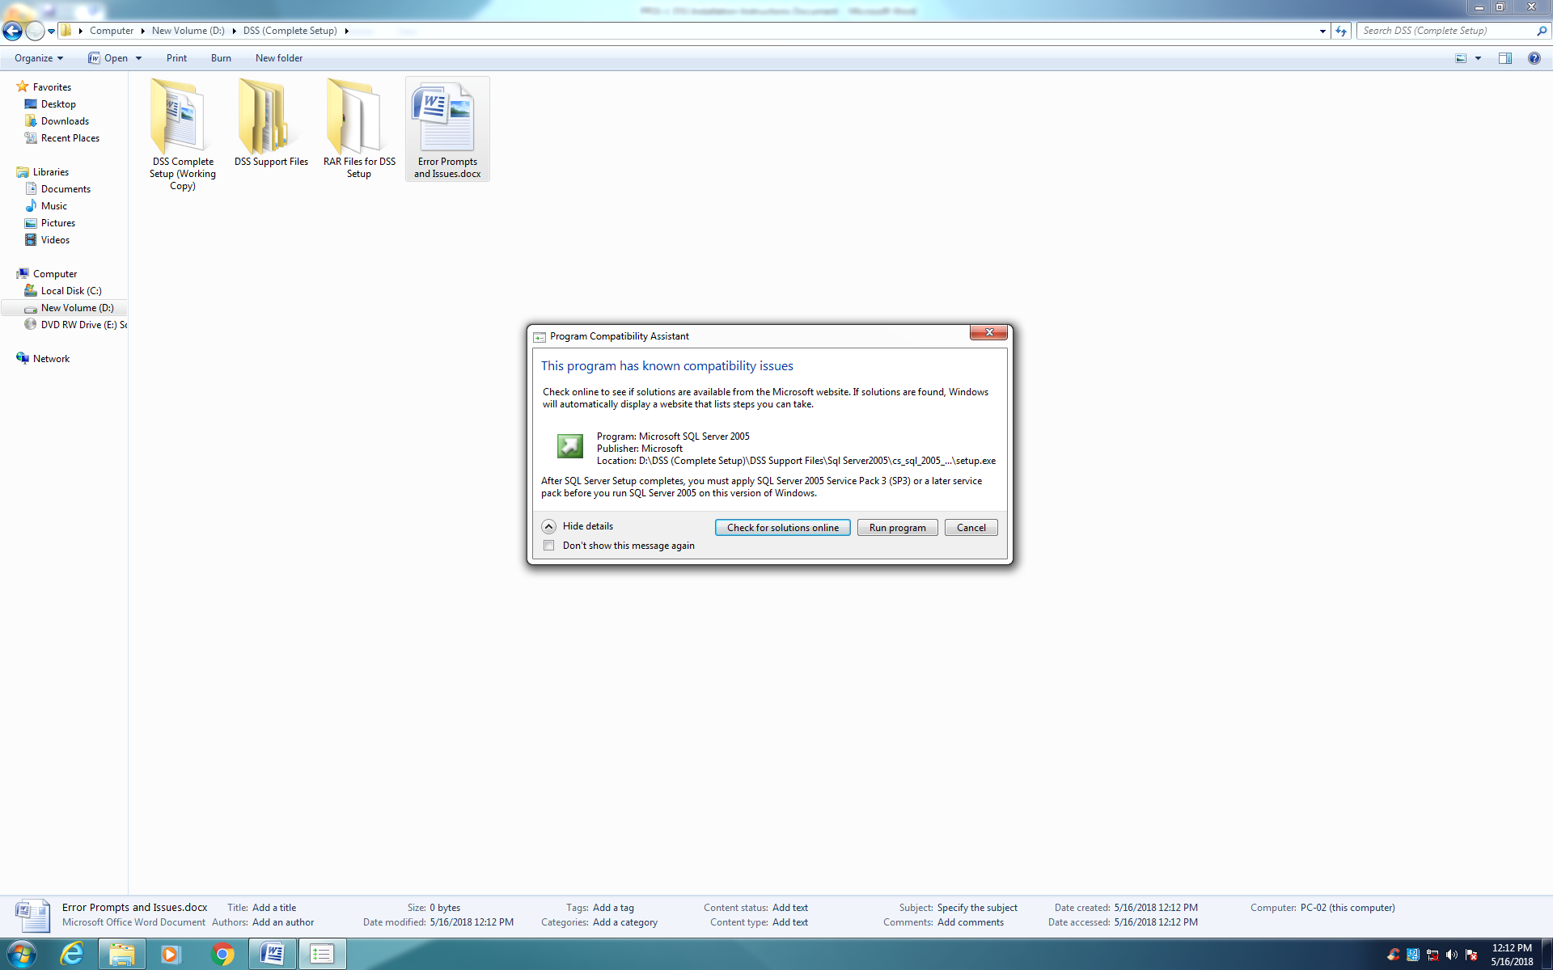

Remarks: Most probable cause of this error is because of this 2005 version of SQL demands a 2005 Visual Studio setup, our machine however has Visual Studio 2008 installed on it.

Possible solution: temporary internet access to the machine in question, as this is a frequent problem with working solutions available online.

3. While SQL 2005 installation:

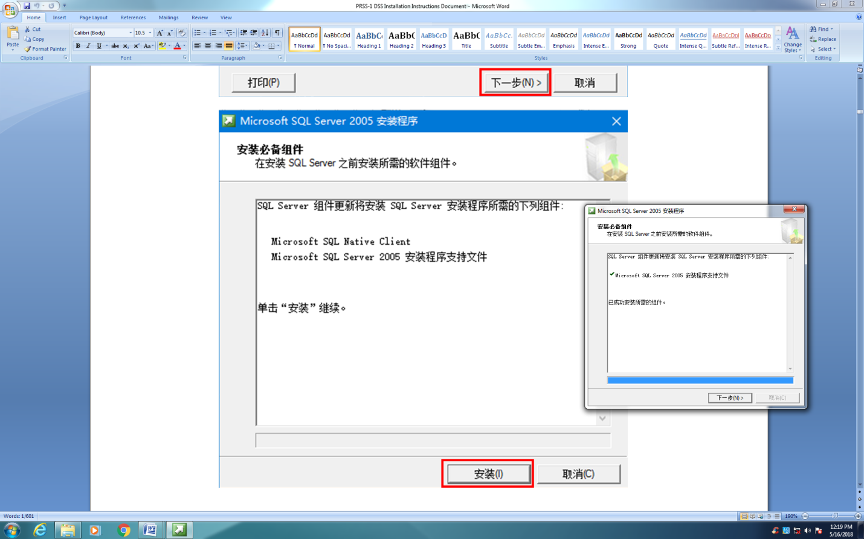

Remarks: A/m discrepency has been noticed. While DSS official documentation (in background) shows successful installation of SQL native client and server, on our machine only SQL is being installed. This might lead to reduced system capabilities/ interfacing errors later on.

4. While SQL 2005 installation:

"

**名称: Microsoft SQL Server 2005 (64 位)**

允许的操作: 维护(只能通过“添加或删除程序”执行此操作)

原因: 无法维护产品。若要维护产品，请转到“添加或删除程序”

**名称: Microsoft SQL Server 2005 Analysis Services (64 位)**

允许的操作: 维护(只能通过“添加或删除程序”执行此操作)

原因: 无法维护产品。若要维护产品，请转到“添加或删除程序”

**名称: Microsoft SQL Server 2005 Notification Services (64 位)**

允许的操作: 维护(只能通过“添加或删除程序”执行此操作)

原因: 无法维护产品。若要维护产品，请转到“添加或删除程序”

**名称: Microsoft SQL Server 2005 Integration Services (64 位)**

允许的操作: 维护(只能通过“添加或删除程序”执行此操作)

原因: 无法维护产品。若要维护产品，请转到“添加或删除程序”

**名称: Microsoft SQL Server 2005 Tools (64 位)**

允许的操作: 维护(只能通过“添加或删除程序”执行此操作)

原因: 无法维护产品。若要维护产品，请转到“添加或删除程序”

"

Remarks: most probable error/ compatibility issues mentioned in detail pertaining to our installation package's preferences selected previously.

5. While SQL 2005 installation:

"

选择的功能中没有任何功能可以安装或升级。由于不会对计算机进行有效更改，安装程序无法继续。若要继续，请单击“上一步”然后选择要安装的功能。若要退出 SQL Server 安装程序，请单击“取消”。

For help, click: http://go.microsoft.com/fwlink?LinkID=20476&ProdName=Microsoft+SQL+Server&ProdVer=9.00.1399.06&EvtSrc=setup.rll&EvtID=SQLSetup90&EvtType=28108

"

Remarks: The previously highlighted issues culminated into this error window.

Possible remedy: link provided to the solution. Internet needed.